WELLBEING PRESCRIPTION
NOTE
Did you know that Cheadle Medical Practice can offer you more types of help than you may think? The Practice Community Champions have been set up to bring the Practice and the Cheadle Community Groups together to improve your health and wellbeing. Check out the list below and if any of these are of interest to you, tick the box, fill in your name and contact details and pop it in at reception. Alternatively, have a chat with one of our Champions to discuss the many options available to you.
You can also email the Champions on: stoccg.cheadlepracticechampions@nhs.net

PART 1
I am interested in receiving more information about the following:

Coffee and a chat – Community social and friendship groups
Social events for Parents – Parent and baby or toddler groups
Creative Activities – Cooking, Crafts, Art, Singing, Creative Writing
Outdoor Physical Activities – Walking, Cycling, Running, Gardening, etc.
Indoor Physical Activities – Keep Fit, Tai Chi, Badminton, Bowling, etc.
I/T Skills – Get familiar with computers & mobiles; from the basics upwards.
Carers Support Groups – Dementia, Stroke, Physical and Mental Health
PART 3 3
Contact Number / email address:
PART 2
I understand that the details I give will be passed to the Practice Community Champions, who will contact me
with the information I have requested.
Date of Birth:
Date:
Signed (Patient):
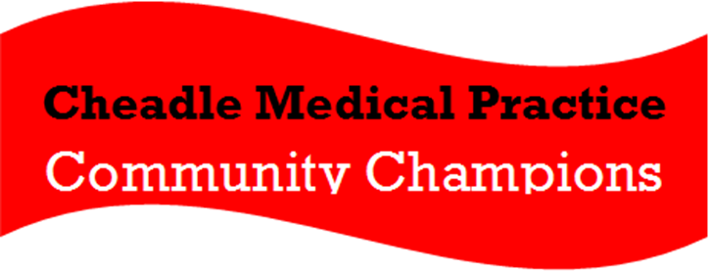
Date of
Birth:
Patient Name:

